**Unit 3**

**Sequences generated by first-order linear recurrence relations**

3.2.10 generate a sequence defined by a first-order linear recurrence relation that gives long term increasing, decreasing or steady-state solutions

3.2.11 use first-order linear recurrence relations to model and analyse (numerically or graphically only) practical problems

**The definition of a graph and associated terminology**

3.3.1 demonstrate the meanings of, and use, the terms: graph, edge, vertex, loop, degree of a vertex, subgraph, simple graph, complete graph, bipartite graph, directed graph (digraph), arc, weighted graph, and network

3.3.2 identify practical situations that can be represented by a network, and construct such networks

3.3.3 construct an adjacency matrix from a given graph or digraph and use the matrix to form multi‑stage matrices to solve associated problems

**Planar graphs**

3.3.4 demonstrate the meanings of, and use, the terms: planar graph and face

3.3.5 apply Euler’s formula, to solve problems relating to planar graphs

**Paths and cycles**

3.3.6 demonstrate the meanings of, and use, the terms: walk, trail, path, closed walk, closed trail, cycle, connected graph, and bridge

3.3.7 investigate and solve practical problems to determine the shortest path between two vertices in a weighted graph (by trial-and-error methods only)

3.3.8 demonstrate the meanings of, and use, the terms: Eulerian graph, Eulerian trail, semi-Eulerian graph, semi-Eulerian trail and the conditions for their existence, and use these concepts to investigate and solve practical problems

3.3.9 demonstrate the meanings of, and use, the terms: Hamiltonian graph and semi-Hamiltonian graph, and use these concepts to investigate and solve practical problems

**Unit 4**

**Compound interest loans and investments**

4.2.1 use a recurrence relation to model a compound interest loan or investment and investigate (numerically or graphically) the effect of the interest rate and the number of compounding periods on the future value of the loan or investment

4.2.2 calculate the effective annual rate of interest and use the results to compare investment returns and cost of loans when interest is paid or charged daily, monthly, quarterly or six-monthly

4.2.3 with the aid of a calculator or computer-based financial software, solve problems involving compound interest loans, investments and depreciating assets

**Reducing balance loans (compound interest loans with periodic repayments)**

4.2.4 use a recurrence relation to model a reducing balance loan and investigate (numerically or graphically) the effect of the interest rate and repayment amount on the time taken to repay the loan

4.2.5 with the aid of a financial calculator or computer-based financial software, solve problems involving reducing balance loans

 **Year 12 Mathematics TEST 2**

**APPLICATIONS UNIT 3&4** TERM 2, 2023

Test Date: Thursday, 11-MAR

***Name:*** _______________________________________________

|  |  |  |  |
| --- | --- | --- | --- |
|  |  | Total | **%** |
| Section 1 |  | **22** |
| Section 2 |  | **34** |
| Total |  | **56** |

*All working is to be shown in the space provided. Your working should be in sufficient detail to allow your answers to be checked readily so part marks may be awarded if the answer is incorrect. For any question worth more than 2 marks valid working or justification must be shown to be awarded full marks.*

**SECTION 1 – Resource Free** **Working Time: 20 minutes**

**Question 1.** [5 marks]

Suzy runs a hobby farm selling Daffodils. Each month the number of daffodils increases by 20% and she picks and sells 80 daffodils.

1. Write the sequence that generates the number of daffodils on her farm after n months if she starts with Q daffodils at the end of the first month. (2 marks)



1. Calculate how many Daffodils she has on her farm if she is at the steady state solution. (3 marks)



**Question 2.** [8 marks]

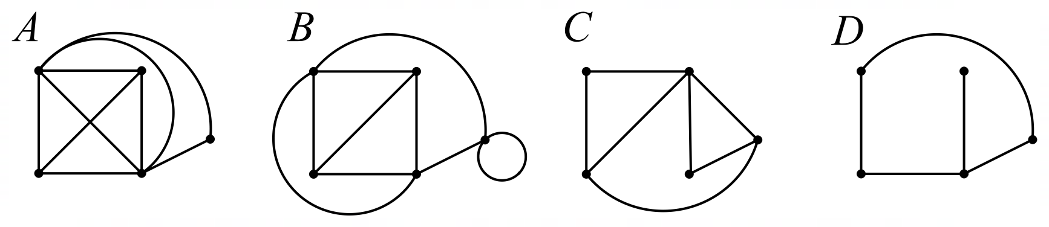Consider Graphs A, B, C and D below:

1. Which, if any, of the graphs are:
   1. Has 4 faces: (1 mark)



* 1. Simple: (1 mark)



* 1. Complete: (1 mark)



* 1. Planar: (1 mark)



* 1. Bipartite: (1 mark)



* 1. A Subgraph of Graph B: (1 mark)



1. If a simple, connected, subgraph of graph A containing all the same vertices was drawn such that it had 7 edges, how many faces would it have? (2 marks)



**Question 3.** [11 marks]

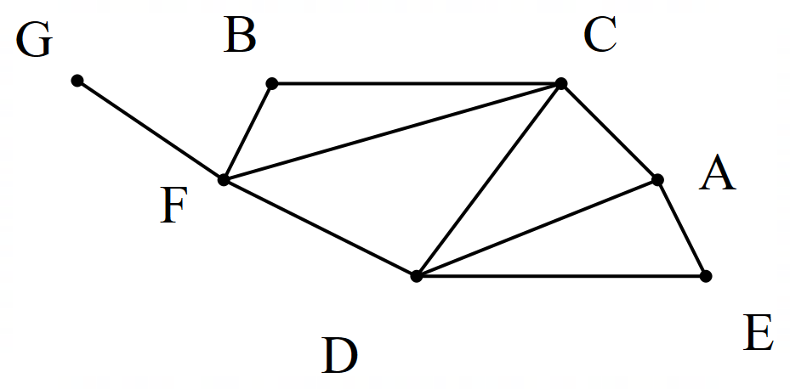Consider the network below:



1. Write all the length 3 walks from A to D. (1 marks)



1. Identify any bridges in the network: (1 mark)



1. Justify why this network is Semi-Eulerian: (1 mark)



**exactly**



1. Write a Semi-Eulerian Sequence of Vertices: (2 marks)



1. Is this network Hamiltonian, Semi Hamiltonian or Neither: (1 mark)



1. Classify the following routes as Walks, Trails, or Paths **and** as Closed or Open (3 marks)
   1. BCBFD



* 1. FCDACB



* 1. CFDAC



***End of Section One***

 **Year 12 Mathematics**

**34**

**APPLICATIONS UNIT 3&4**

**TEST 2**

**SECTION 2 – Resource Rich**

**NOTES (0 marks)**

❑ Outstanding

❑ Great quality

❑ Good

❑ Simple

❑ No notes

**Working Time: 30 minutes**

***Name:*** ________________________________________

**Question 4** [7 marks]

1. Fill in the adjacency matrix for the following graph: (2 marks)

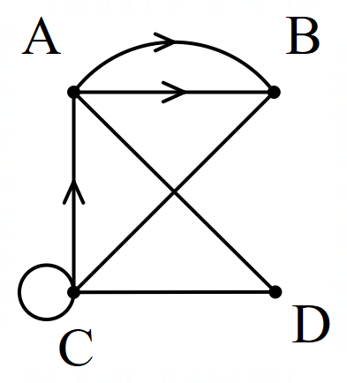

|  |  |  |  |  |
| --- | --- | --- | --- | --- |
|  | A | B | C | D |
| A |  |  |  |  |
| B |  |  |  |  |
| C |  |  |  |  |
| D |  |  |  |  |

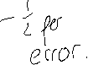

1. A different graph is has an adjacency matrix (M) as follows:

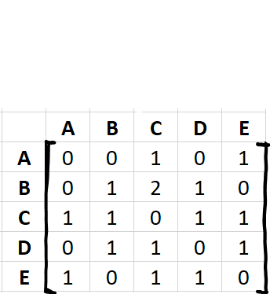

M=

1. What two pieces of information in this adjacency matrix show that the graph is not simple?

(2 marks)



1. What piece of information in this adjacency matrix indicates that it is a digraph? (1 mark)



1. Determine how many length 5 walks are there from B to D? Justify your answer. (2 marks)

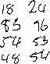

**Question 5** [6 marks]

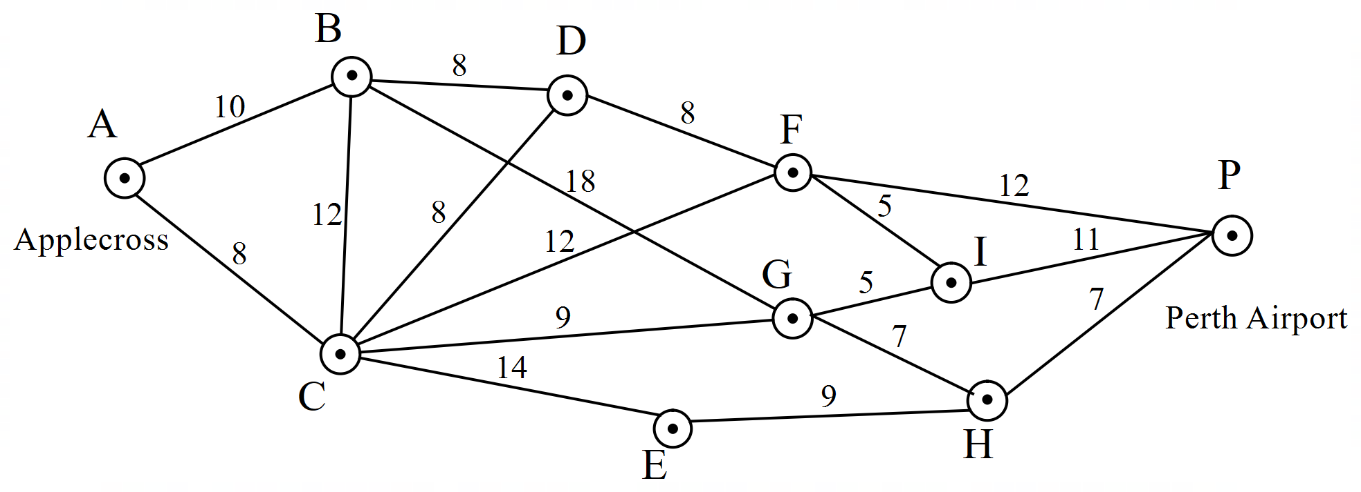Mr Macey is trying to get to Perth Airport as soon as possible. He has created a map of the travel times between locations between Applecross SHS and Perth Airport.



1. By marking up the diagram above, what is the time required, and which route must be taken to get from Applecross (A) to Perth Airport (P) as fast as possible? (4 marks)



1. By cutting across a park, Mr Macey can reduce his travel time from A to B. How much time does he need to take off here to change the shortest path, and what does it become? (2 marks)



**Question 6** [8 marks]

A real estate agent is selling a house with a room layout as shown below.

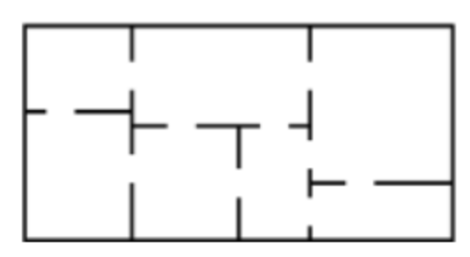

1. Draw a graph below to represent the house as a network. (2 marks)

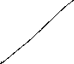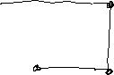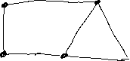

1. What do your vertices represent? When do you put an edge between vertices? (2 marks)



1. It is currently not possible to pass through each door in the house exactly once while starting and finishing at the same location. Justify why this is the case. (2 marks)



1. What would need to be done to make this possible? Describe this new graph. (2 marks)



**Question 7** [13 marks]

Anthony is taking out a 10,000 dollar loan for some new golf clubs after his old set fell into a lake. He is short on cash and decides to take a loan out to pay for the clubs. He finds two banks, HM Bank which offers him a loan at 5.5% annual interest compounding monthly and DC bank which offers 5.45% annual interest compounding daily.

1. Calculate the effective annual interest rate (to 2 decimal places) for both loans. (2 marks)



1. Due to HM bank offering free golf lessons with every loan, Anthony decides to borrow the 10,000 dollars from them, repaying 310 dollars a month
   1. Write a recurrence rule that will generate how much Anthony owes on the loan after n payments. (2 marks)



* 1. Fill in the table below to calculate how long it takes to pay off the loan? (3 marks)



|  |  |
| --- | --- |
| Compound Interest | |
| N: |  |
| I% |  |
| PV: |  |
| PMT: |  |
| FV: |  |
| P/Y: |  |
| C/Y: |  |

* 1. What will be the value of Anthony’s final repayment? (2 marks)



* 1. How much interest will he have paid over the life of the loan? (2 marks)



1. 1 year into the term of the loan, Anthony wins a golf tournament. As a result he wants to finish paying off his loan in the next 6 months. What are his new monthly repayments? (2 marks)



**Question 10 (6 marks)**

A grain silo stood empty at the start of a harvest. Over the next month, the weight of barley in the silo, tonnes at the end of the day, was modelled by .

1. Determine, to the nearest tonne, the change in the weight of barley in the silo from the end of day to the end of day . (2 marks)



1. At the end of which day did the weight of barley in the silo first exceed tonnes? (1 mark)



1. Eventually, the weight of barley will reach a steady state. At the end of which day did the weight of barley in the silo first come within a quarter of a tonne of the steady state? Justify your answer.

(3 marks)



***End of Test***